Naman Singh CU24250110 Labsheet 5 roll no. 43

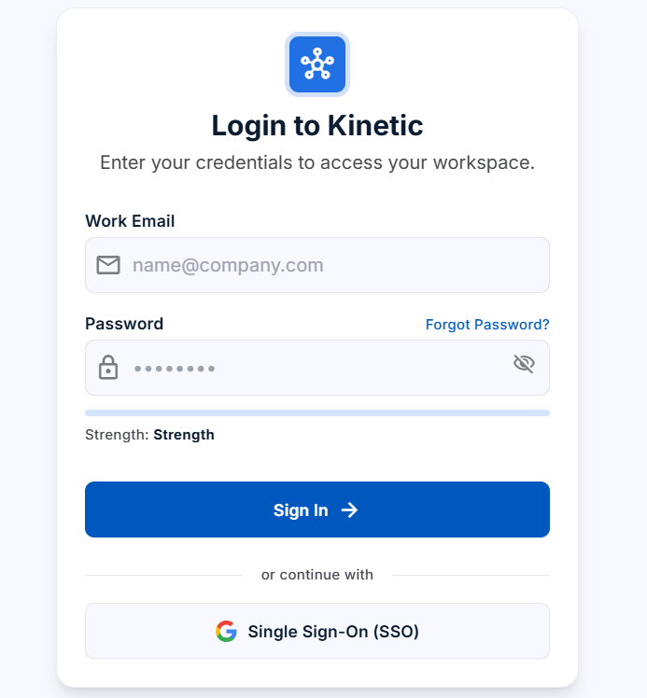
import { useMemo, useState } from "react";
import {
Eye,
EyeOff,
Check,
X,
AlertCircle,
ArrowLeft,
ArrowRight,
BadgeCheck,
} from "lucide-react";

/*
LAB 05
Refactored version:
- Different component names and structure
- Validation is centralized in helper functions
- Shared input component instead of the original Field wrapper
- Different layout/styling approach
- Same core behavior: regex validation, password meter,
login form, and four-step onboarding flow
*/

// -----------------------------
// Validation helpers
// -----------------------------

const EMAIL_PATTERN = /^[^\s@]+@[^\s@]+\.[^\s@]{2,}$/;

const PASSWORD_CHECKS = [
{
id: "minLength",
text: "8 or more characters",
validate: (value) => value.length >= 8,
},
{
id: "capital",
text: "An uppercase letter",
validate: (value) => /[A-Z]/.test(value),
},
{
id: "small",
text: "A lowercase letter",
validate: (value) => /[a-z]/.test(value),
},
{
id: "number",
text: "A number",
validate: (value) => /\d/.test(value),
},
{
id: "symbol",
text: "A special character",
validate: (value) => /[^A-Za-z0-9]/.test(value),
},
];

const TRACKS = [
"Web development",
"Machine learning",
"Full stack",
"Data science",
];

const WIZARD_STEPS = [
"Personal",
"Account",
"Interests",
"Confirm",
];

const passwordScore = (value) =>
PASSWORD_CHECKS.reduce(
(total, rule) => total + (rule.validate(value) ? 1 : 0),
0
);

const strengthInfo = (value) => {
const score = passwordScore(value);

const labels = [
["", "#9ca3af"],
["Very weak", "#dc2626"],
["Weak", "#ea580c"],
["Fair", "#d97706"],
["Strong", "#16a34a"],
["Very strong", "#15803d"],
];

const [label, color] = labels[Math.min(score, 5)];

return { score, label, color };
};

const validateLogin = ({ email, password }) => {
const result = {};

if (!email.trim()) {
result.email = "Email is required";
} else if (!EMAIL_PATTERN.test(email)) {
result.email = "Enter a valid email address";
}

if (!password) {
result.password = "Password is required";
} else if (passwordScore(password) !== PASSWORD_CHECKS.length) {
result.password = "Password does not meet the security policy";
}

return result;
};

const validateStep = (step, profile) => {
const result = {};

if (step === 0) {
if (!profile.fullName.trim()) {
result.fullName = "Full name is required";
}

if (!profile.email.trim()) {
result.email = "Email is required";
} else if (!EMAIL_PATTERN.test(profile.email)) {
result.email = "Enter a valid email address";
}
}

if (step === 1) {
if (!profile.username.trim()) {
result.username = "Username is required";
}

if (!profile.password) {
result.password = "Password is required";
} else if (passwordScore(profile.password) !== PASSWORD_CHECKS.length) {
result.password = "Password does not meet the security policy";
}
}

return result;
};

// -----------------------------
// Shared UI
// -----------------------------

const styles = {
shell: {
maxWidth: 480,
margin: "32px auto",
padding: "0 18px",
fontFamily: "Inter, system-ui, -apple-system, sans-serif",
color: "#1f2937",

